Day2 Tasks:

Locator:

1. Facebook page

Enter Email or Phone and password

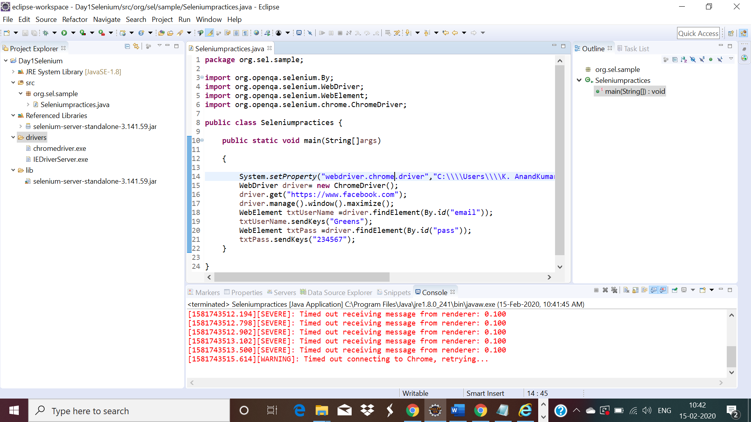

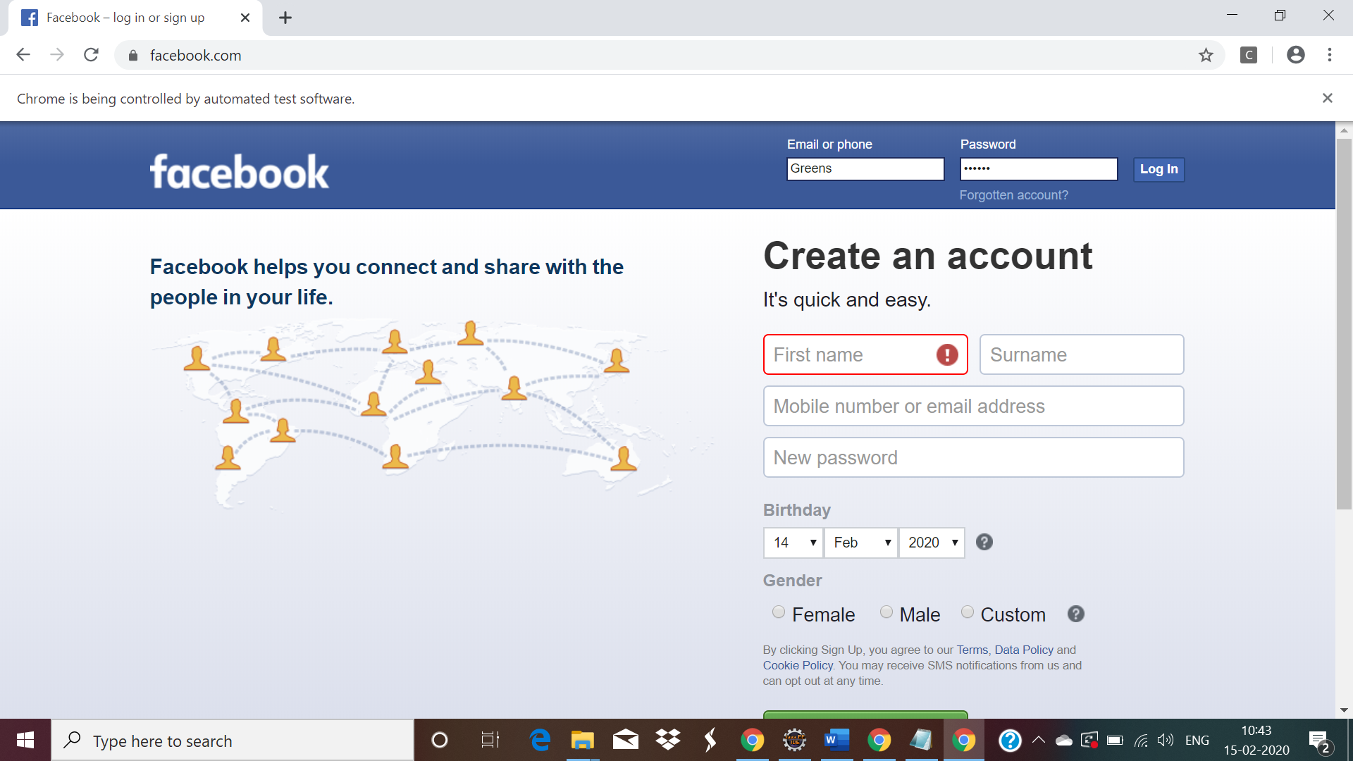

2. URL : https://www.redbus.in/

NOTE: Enter from and to textbox.

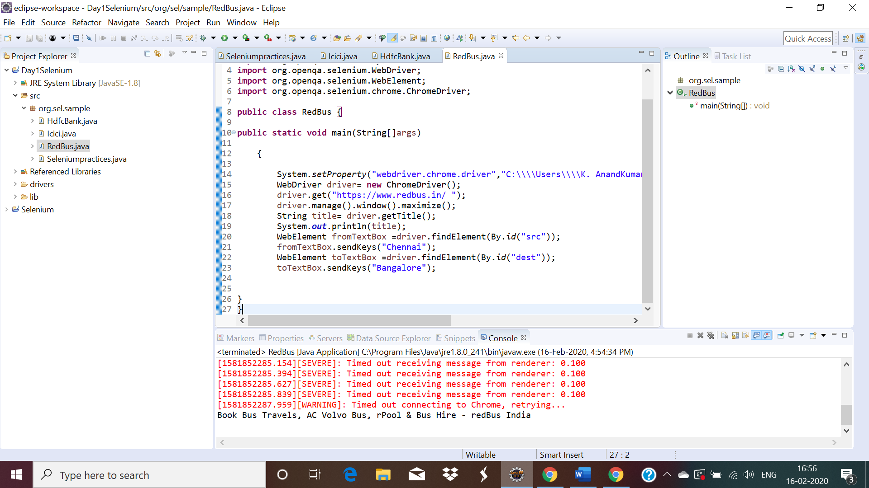

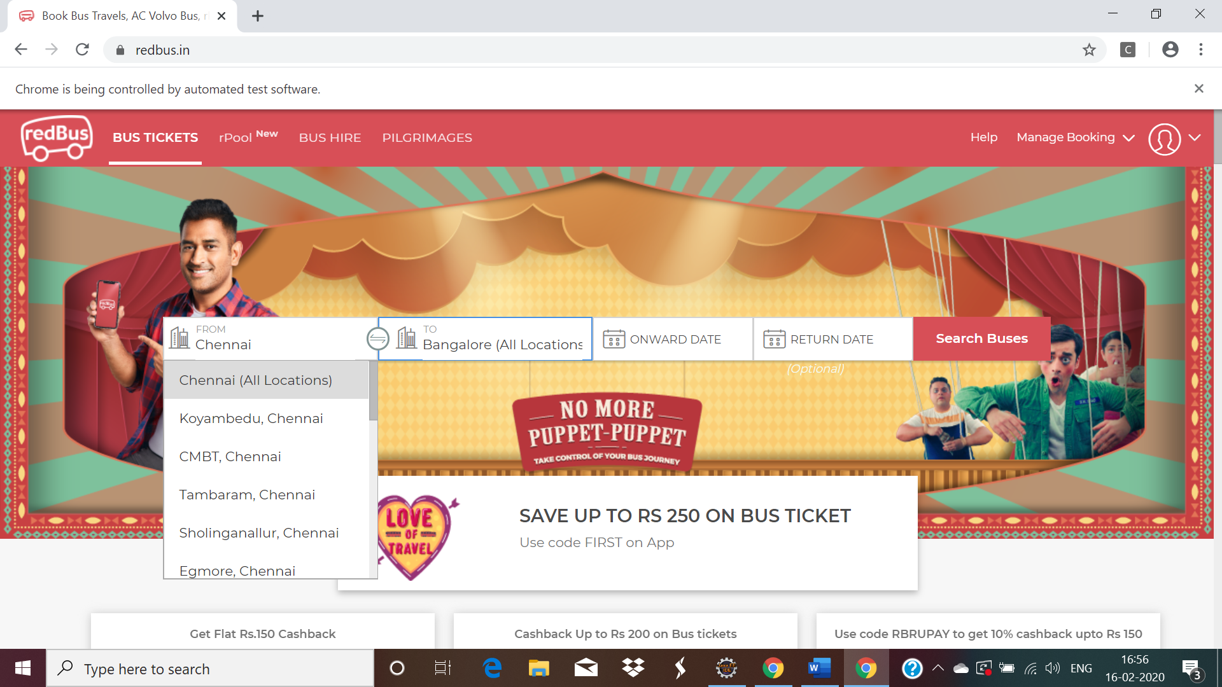

1. Google page: Enter Greens Technologies

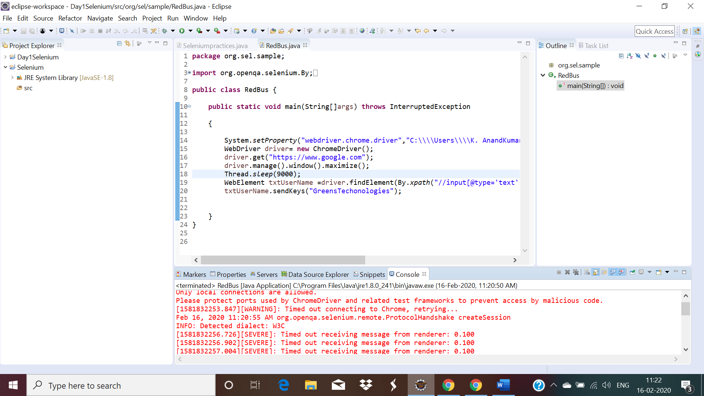

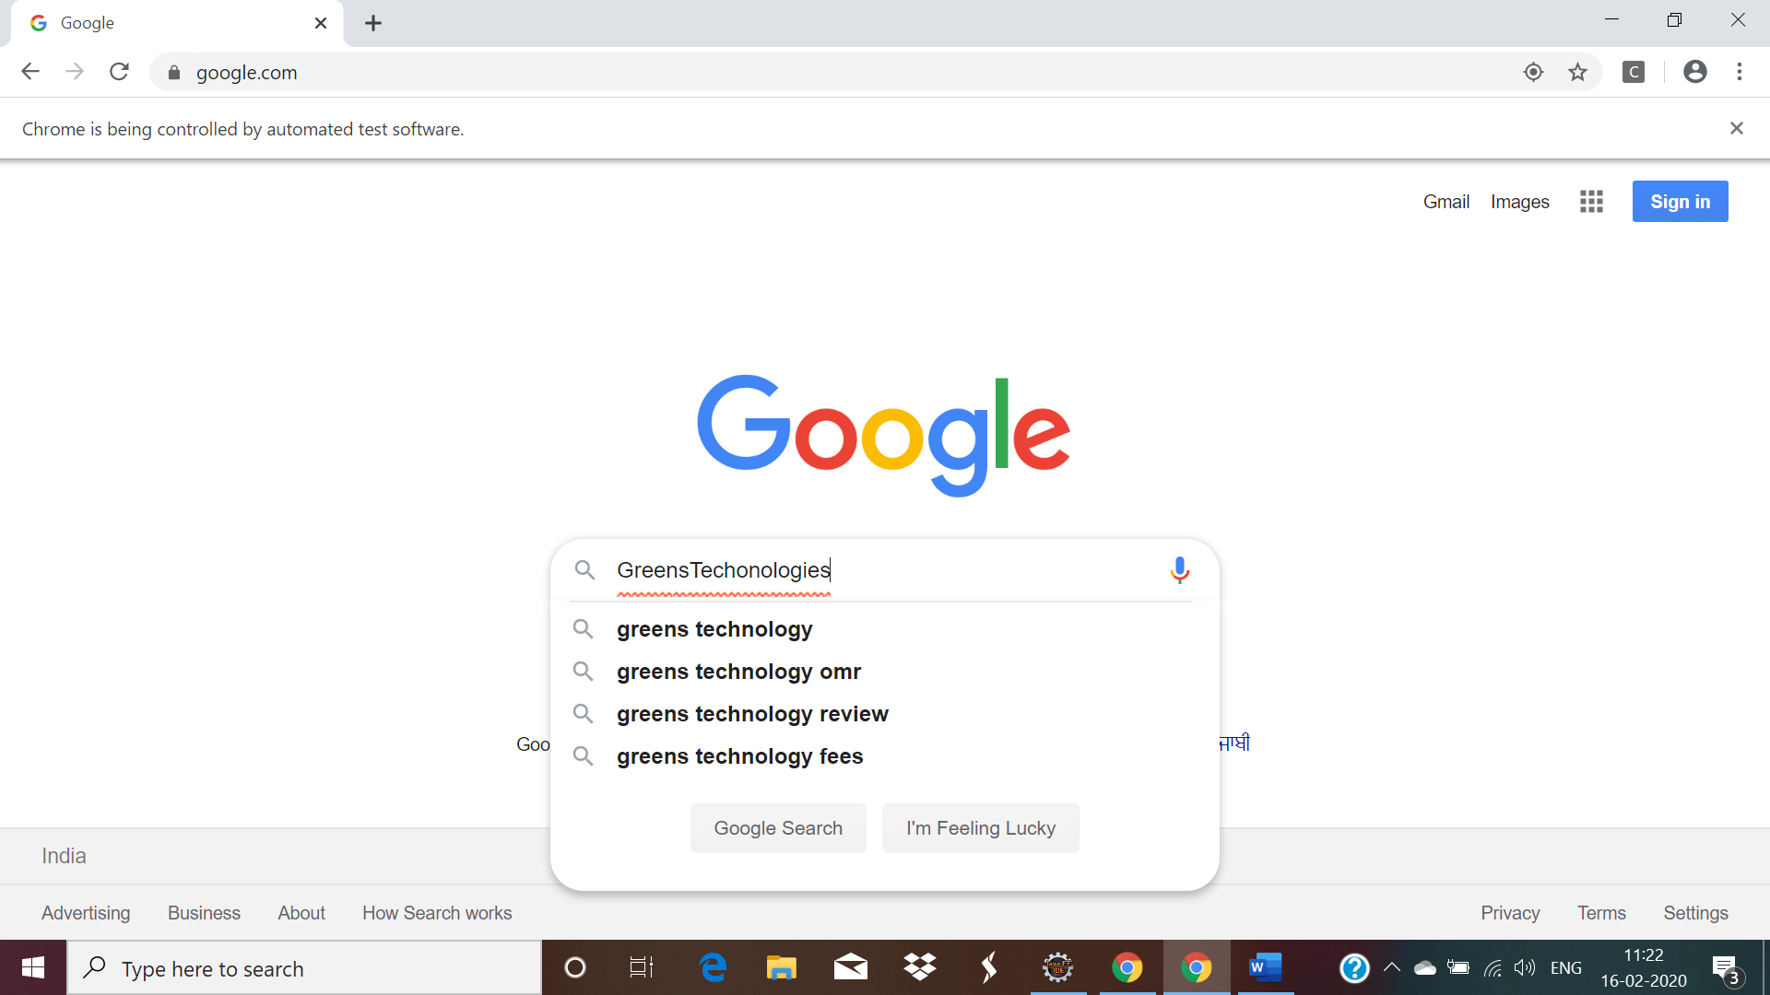

4. URL : https://www.swiggy.com/

NOTE: Enter the location.

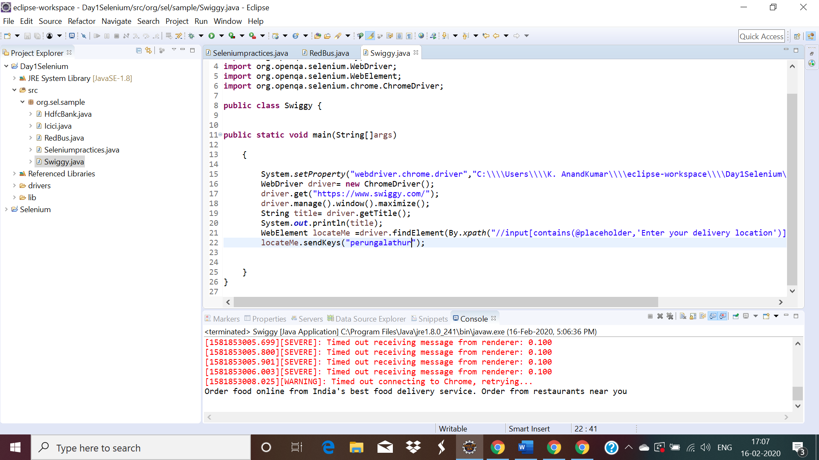

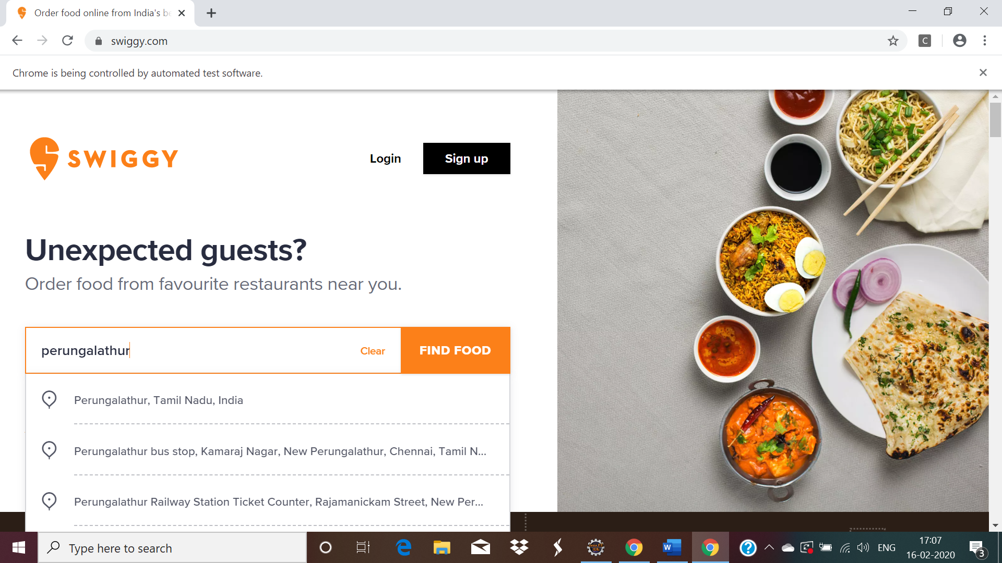

5. URL :https://www.snapdeal.com/login

NOTE: Enter mobile number/email.

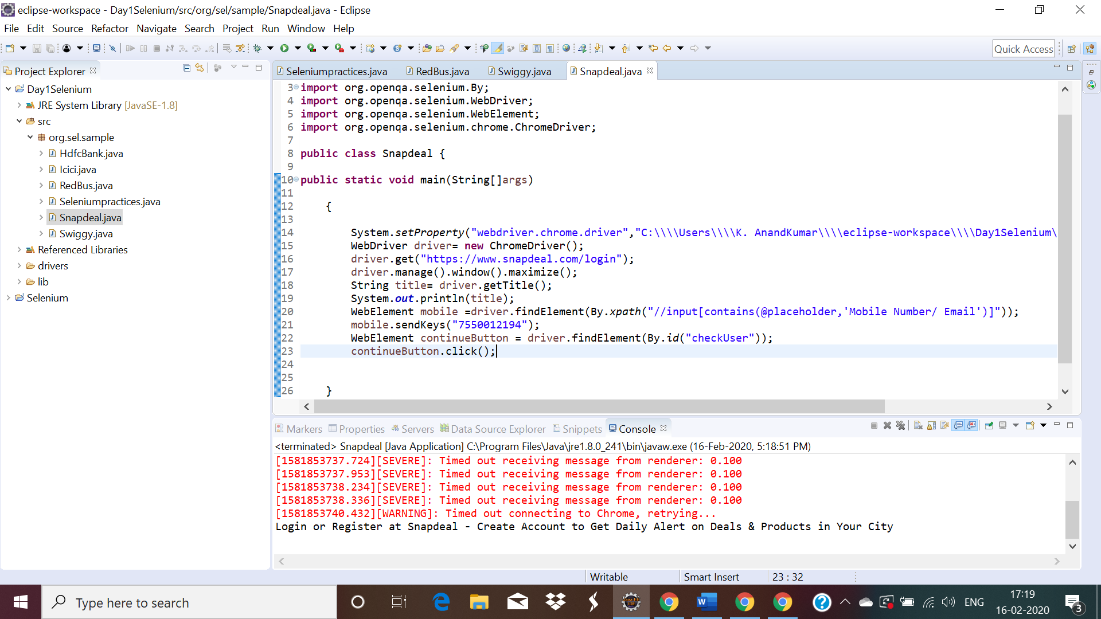

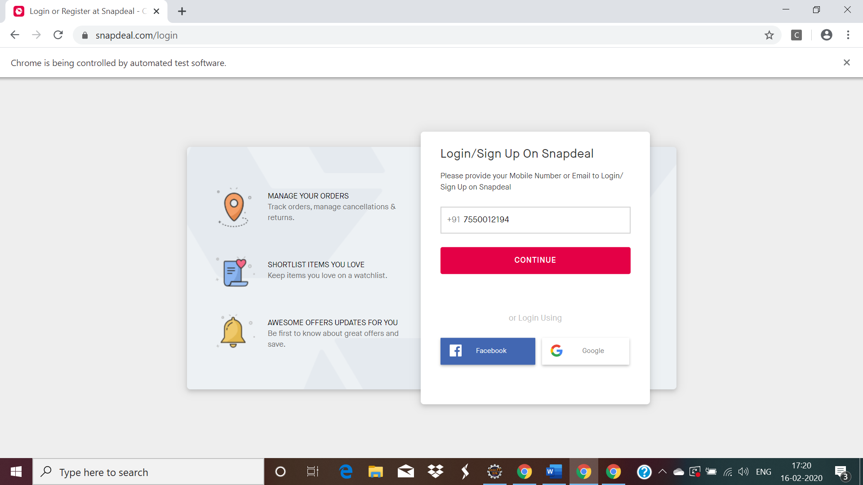

6. URL : https://www.instagram.com/accounts/login/?hl=en) login page

NOTE: Enter username and password.

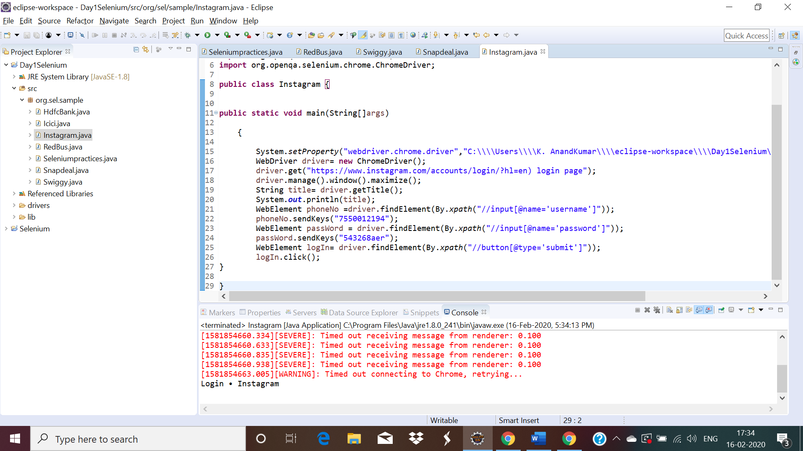

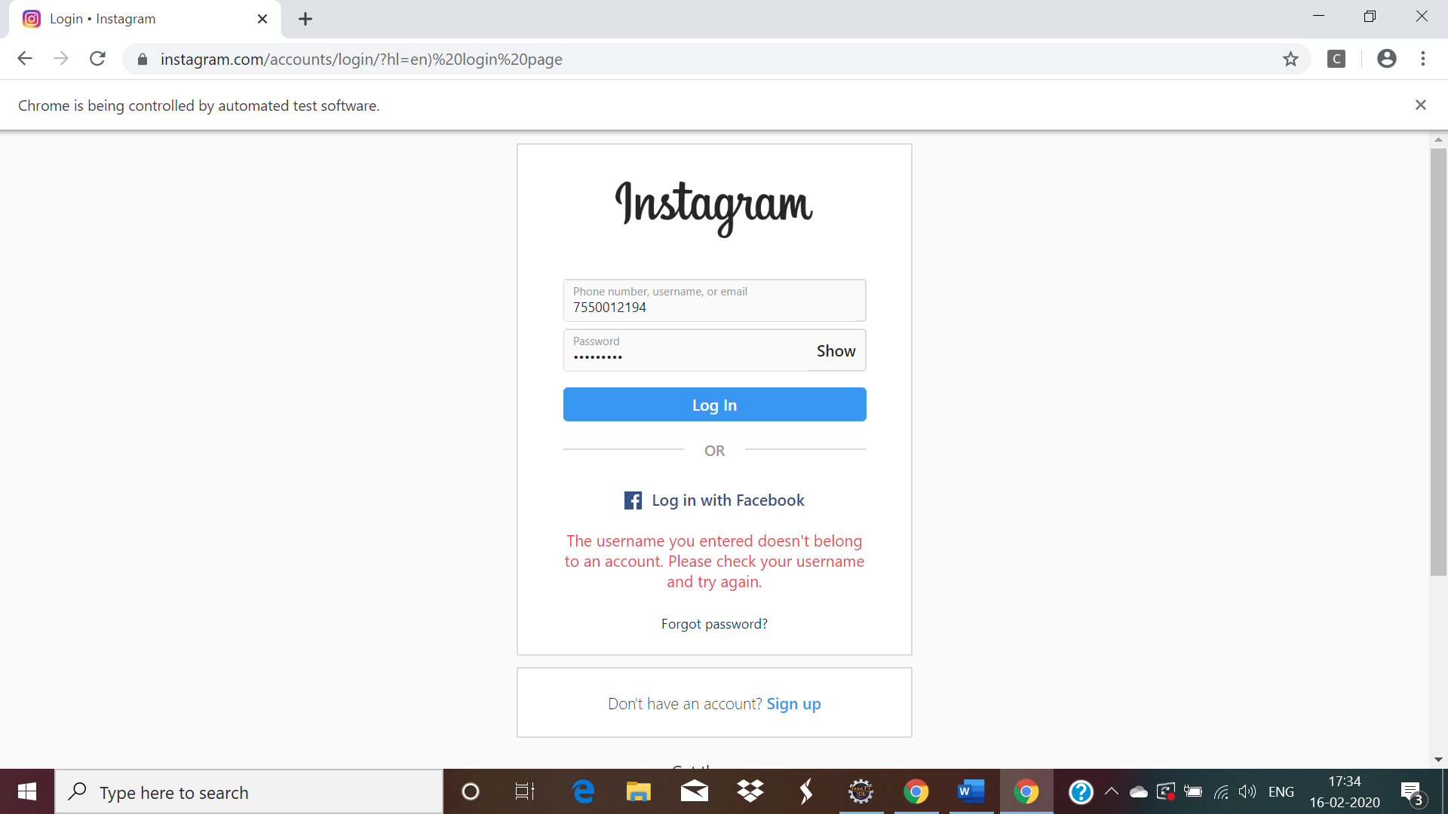

7. URL : https://www.irctc.co.in/

NOTE: Just enter the values for the textbox only.

